Peer Review:

Name: Minimal Wire Use

Details: Use as little wire as possible when wiring components. This will make your breadboard cleaner to work with and reduce chance of mis-wiring.

Level: Low

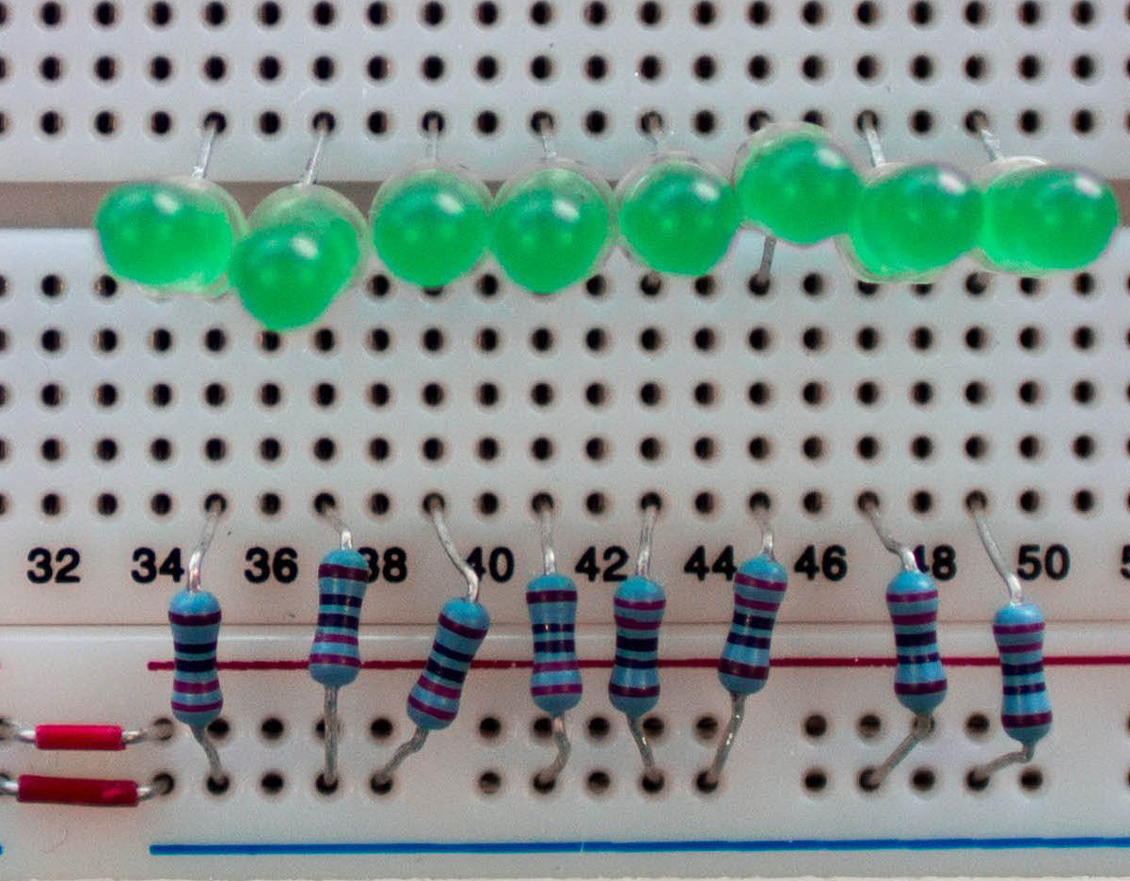

[Good Example] [Bad Example]

Name: Color code your wires

Details: Color coded your circuit wires if possible (e.g., Red for power) and keep the color coding consistent.

Level: Medium

[Good Example] [Bad Example]

Name: Separate Long Leg Components

Detail: Avoid two components with long legs getting too close. The exposed legs may touch each other, resulting in a short circuit.

Level: High

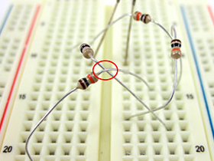

[Good Example] [Bad Example]

Name: Don't Wire Over ICs

Details: Avoid laying wires or components over ICs. Go around ICs if at all possible. This will help prevent your circuit from malfunctioning.

Level: Medium

[Good Example] [Bad Example]

Name: One Pin Per Socket

Details: Do not insert two pins of different components or two jumper wires into a same socket. This will cause your circuit to behave unpredictably. Only put one pin or wire into a socket.

Level: High

[Good Example] [Bad Example]

Name: Connect to Power Rails

Details: Use the power rails to connect power supply (red -> positive/ blue -> negative) instead of other 5-pin arrays. This will allow more sockets to have access to power and keep your circuit organized.

Level: Medium

[Good Example] [Bad Example]

Name: Avoid Crossing Wires

Details: When wiring your circuit, avoid crossing wires if at all possible. This will help keep your circuit organized and easier to work with.

Level: Medium

[Good Example] [Bad Example]

Name: Trim Long-Leg Components

Details: If your component has long legs, use the wire cutter to clip the legs as short as possible. This will allow your component to be closer to the board. Remember that your legs still need to reach the bottom of the breadboard (so don't trim too short!)

Level: Low

[Good Example] [Bad Example]

Quiz:

Name: Check Component’s Value

Details: Measure the component's value (resistance/ capacitance/ inductance) using a multimeter before insertion into breadboard. This will ensure that your component is functioning properly.

Level: Medium

Question: Did you check your component value before inserting into breadboard?

Correct Answer: Yes

Other Answers: No, Not Sure

[Good Example]

Name: Check Polarity

Details: Make sure the polarized component's polarity is correct before insertion (e.g., Batteries, LEDs, etc.) using a multimeter. This will ensure that your component is facing the correct direction when inserted.

Level: High

Question: Did you check your component polarity before inserting into breadboard?

Correct Answer: Yes

Other Answers: No, Not Sure

[Good Example]

Name: Verify Power Supply

Details: Always verify the power supply voltages and input signals (i.e., function generator signals or signals from other modules) with the multimeter before use.

Level: High

Question: What is the supply voltage of the battery box?

Correct Answer: 3V

Other Answers: 5V, 9V, Not Sure

[Good Example]

Name: Check IC Part Number

Details: Check IC part number before insertion. This will make sure you are using the correct component. The IC part number is located on the top of the component.

Level: Medium

Question: What is the part number of the motor driver IC?

Correct Answer: L293D

Other Answers: S126D, P3N15, L901R

[Good Example]

Name: Check IC’s Direction

Details: Check IC’s direction before insertion. Please make sure the small dot on the IC (e.g., indicating pin 1) matches the IC’s dot on the breadboard figure. The dot is located on the top of the component.

Level: Medium

Question: Did you check your IC’s direction before inserting into breadboard?

Correct Answer: Yes

Other Answers: No, Not Sure

[Good Example]

Sequence Based:

Begin by fixing the ICs first. Then start connecting the remaining relevant components to the breadboard sockets which directly reach out to the IC pins.

Always connect the batteries or power supply to the circuit last, check the whole circuit and then power the circuit

Build and test in subsections